Software engineering for AI

techniques

Lab assignment

NAME: SRIJANIK BHOWMIK

REG NO: 192111200

DAY: 2

1. Draw a USE-CASE diagram for Online Railway Reservation System using CASE tools

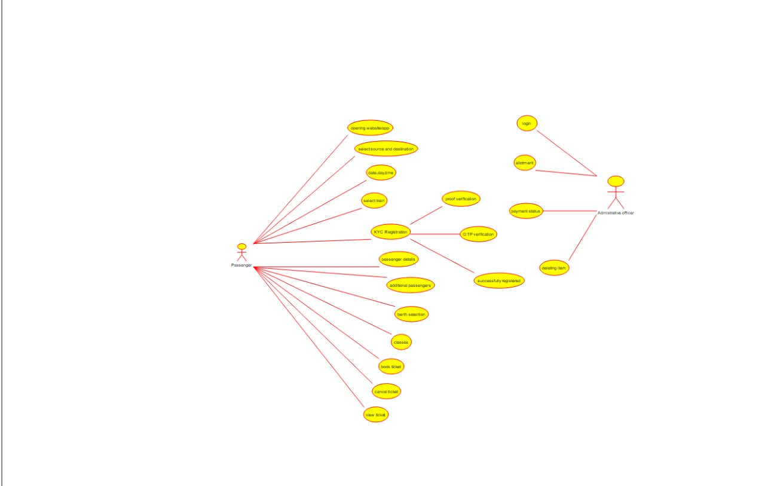

1. Draw a USE-CASE diagram for Hospital Management System using CASE tool

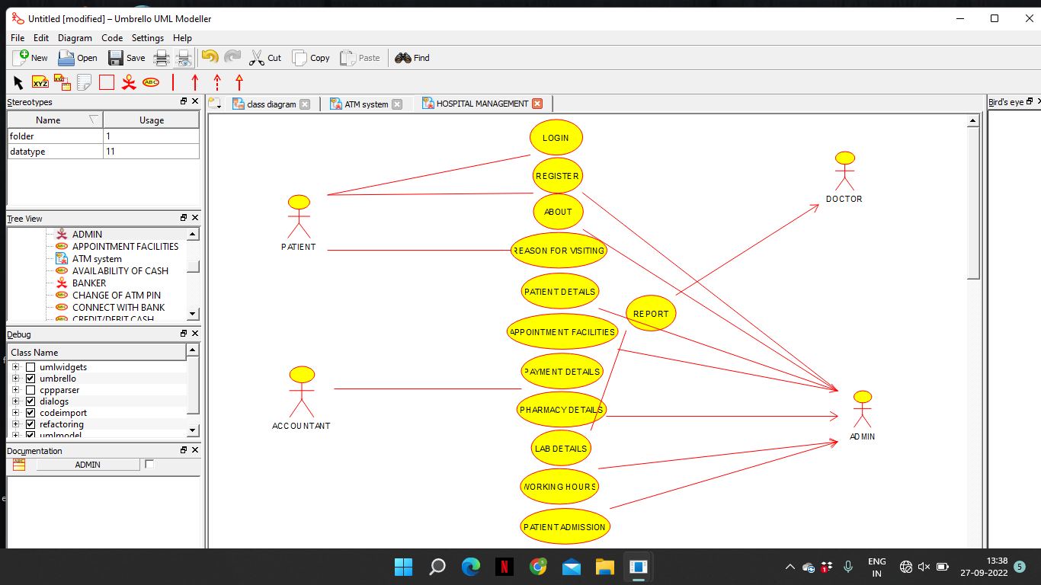

1. Draw a USE-CASE diagram for ATM System using CASE tools.

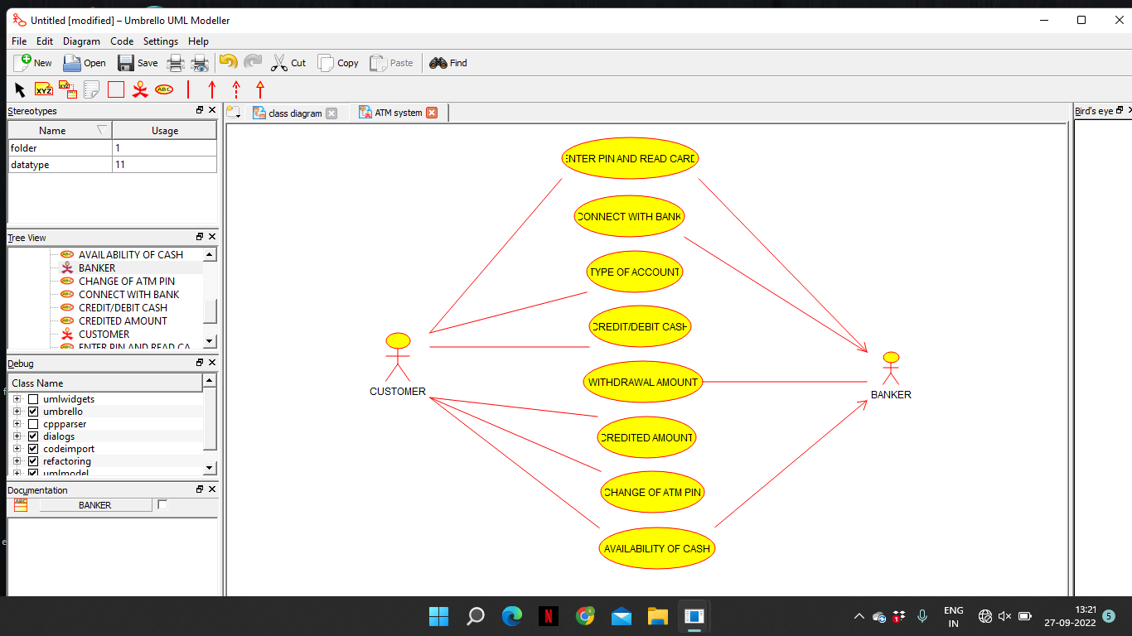

4.Draw a USE-CASE diagram for Online Shopping System using CASE tools

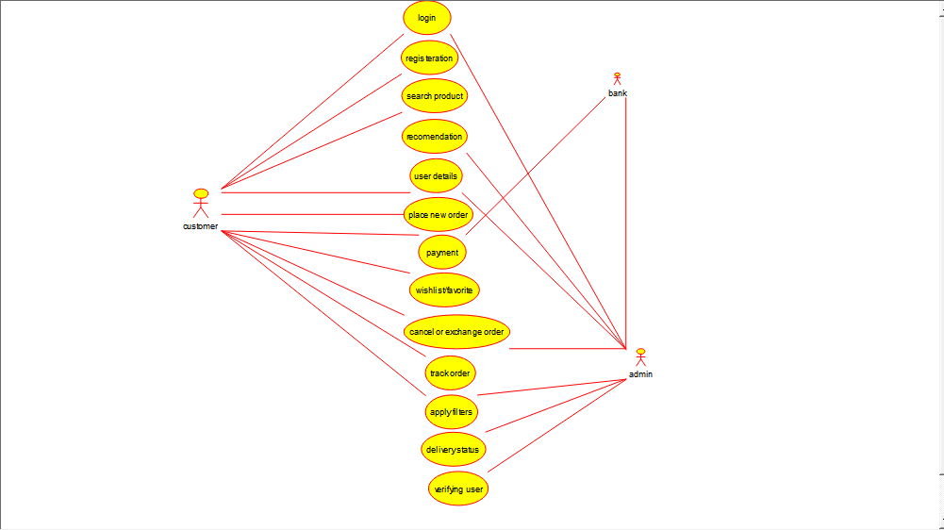

5.Draw a USE-CASE diagram for Online Airline Reservation System using CASE tools.

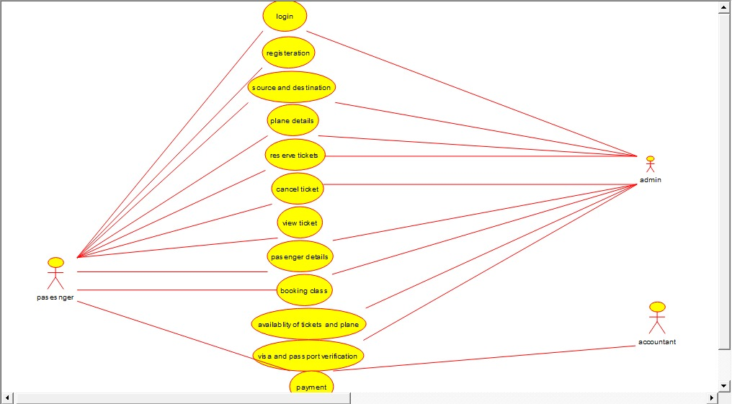

6. Draw a Class diagram for Online Airline Reservation System using CASE tools

